**Booking form and hire agreement**

|  |  |
| --- | --- |
| **Name of responsible adult** |  |
| **Contact telephone No.** |  |
| **Email Address** |  |
| **Use /Activity proposed** |  |
| **Start and Finish Times** |  |
| **Will you use the hob/oven?** |  |
| **Will you use the coffee machine?** |  |
| **Will you use the dishwasher?** |  |
| **Signed: Print Name: Date:** | |

**Please note that you are the person responsible and must secure all doors, switch off lights, check taps etc.**

**In the event of a fire you must evacuate the building by the nearest fire exit(s) and assemble at a designated assemble point and dial 999.**

**Please leave the building as you found it. Vacuum the Chapter House ready for the next person.**

**You are responsible for the behaviour of anyone using the facilities in connection with your hire. The facilities are used entirely at your own risk and the Parochial Church Council of St. Robert’s, Pannal shall not be liable for any loss, damage, accident or mishap arising from your hire. We advise that you obtain relevant insurance for your time at our premises.**

**St Robert’s Church**

***Registered Charity No. 113698***

**Main Street**

**Pannal**

**Harrogate**

**HG3 1JZ**

[**www.strobertschurch.co.uk**](http://www.strobertschurch.co.uk)

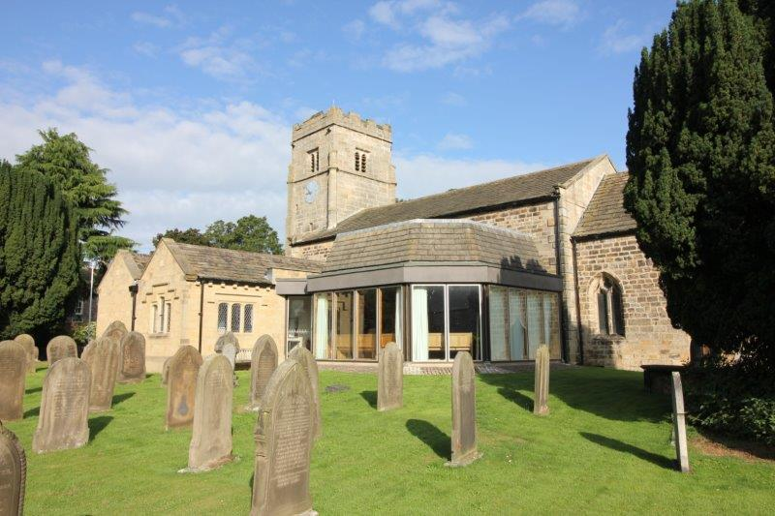

**Booking Form and Hire Agreement**

**General Points**

We hope that you will enjoy using our beautiful building. These notes are sent to each group who are using the facilities so that we communicate the many things available as part of the hire. The kitchen is very well equipped, please ask for specific details.

Please leave the premises in the state that you would like them left for yourself : clean & tidy.

**Setting up and what to bring.**

Tables are available, as are numerous chairs.

A Piano is usually available in the Chapter House. Please ask at the time of booking

Tea towels, dishcloths, washing up liquid, crockery is available.

A large water boiler, coffee machine and dishwasher are available.

You will need to bring fair trade tea, sugar & coffee with you (the coffee machine needs filter coffee).

We have details of local caterers if you need them.

A fridge is available for your use, please remove all foodstuffs at the end of the hire period.

**Food Hygiene**

It is important that each group using the kitchen ensures that the standard of hygiene is as high as possible.

**Children**

For safety reasons, children under the age of 16 are not permitted in the kitchen.

**First Aid Kits and Fire Exit**

Please familiarise yourself on arrival with the whereabouts of fire exits/fire extinguishers. A first Aid Kit is situated in the kitchen.

**Tidying Up Afterwards**

Please ensure that the Chapter House floor is vacuumed prior to leaving.

Please leave the kitchen clean and tidy. Basic cleaning materials can be found under the sink, bin bags are either in the drawer facing the Chapter House serving hatch/on the shelf in the Chapter House Store Cupboard.

Please empty the kitchen bins and tie all used bags securely prior to putting in the black outside refuse bin. New bags should be put into the newly emptied bin(s).

|  |  |
| --- | --- |
| **Cost of Hire for the Chapter House Facilities** | |
| Half Day | £40 |
| Evening | £40 |
| Concessions (half day/Evening) | £30 |
| Full day | £75 |
| Concession (Full Day) | £60 |
| **Cost of hire for Whole Church per day** | **£125** |